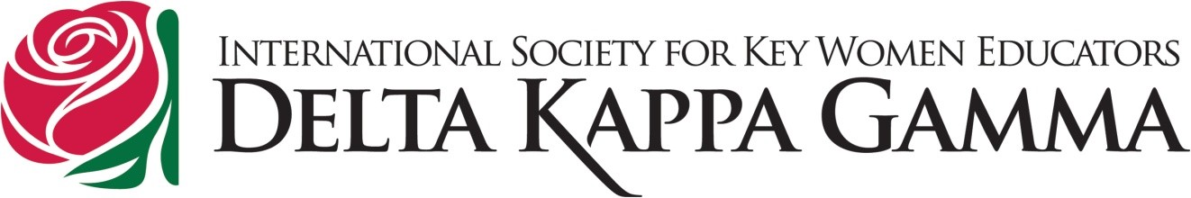

BEAR Project – 1st Year Evaluation by Teachers

Do you like having the BEAR program at the school?

Did you have a student who was a part of the BEAR program?

Did you see any excitement in your student(s) about this program?

Do you think the program impacted your student’s desire to read?

Is there anything else you’d like to comment on regarding the BEAR program?

What positive impact has the program had on your school community?

